Media Contact:
Paden Brown, paden@epic.inc
Katie Bell, katie@epic.inc

Finding the Hero in your Husband Empowers Women to Build Intimacy in Marriage

Dr. Juli Slattery’s Revised Version Teaches Women to Examine Their Hearts and Encourage the Hero within Their Husbands
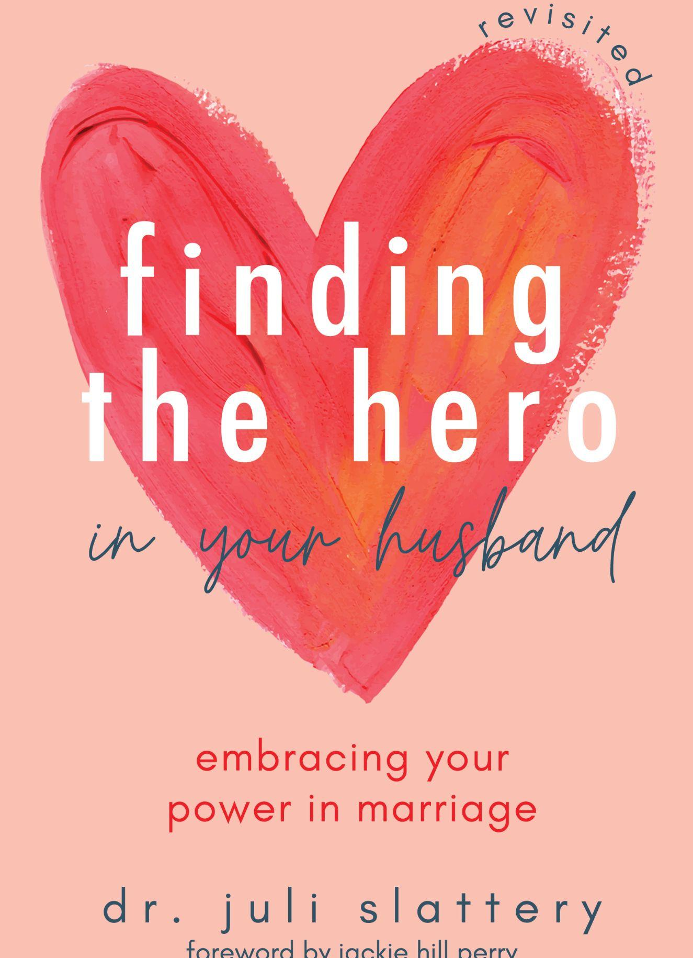
Akron, Ohio (Sept. 8, 2021) – In a complete rewrite of her bestselling book, Finding the Hero in Your Husband: Embracing Your Power in Marriage (HCI Books, October 2021), acclaimed psychologist and speaker Dr. Juli Slattery encourages wives to see how their attempts to manage the messiness of life and marriage actually work against them to undermine the very connection they want to build.

Today’s women have realized the power in thinking for themselves and using their gifts, talents and strengths to improve their lives. Now the tension lies in a woman using her power in a manner that builds intimacy with her husband rather than destroying it.

“I’ve seen God use the principles I wrote about in the original book over the past twenty years. In this rewrite, I’ve adapted those truths to the real-life challenges women face today. I want to offer hope and practical tools to build intimacy in marriage,” Dr. Slattery says.
Dr. Slattery uses sound theology to challenge misconceptions and outright misinformation taught by the larger culture as well as the church. Grounded in biblical truth, Finding the Hero in Your Husband, Revisited works its way through every corner of marriage, from work life to home life, conflict to sexual intimacy, and respect to boundaries in an attempt to help a wife more clearly see and encourage the hero within her husband by examining her own heart.
ABOUT THE AUTHOR:
Dr. Juli Slattery is a clinical psychologist, author, speaker and broadcast media professional with over twenty-five years of experience counseling, discipling, and teaching women. She’s the president and co-founder of Authentic Intimacy, a unique ministry devoted to teaching God’s design for intimacy and sexuality. In 2020, Juli launched SexualDiscipleship.com, a platform designed to help Christian leaders navigate sexual issues and questions with gospel-centered truth. She hosts a weekly podcast, Java with Juli, where she answers tough questions about relationships, marriage, and spiritual, emotional and sexual intimacy.
To learn more, please visit www.authenticintimacy.com or follow Juli on Twitter www.Twitter.com/DrJuliSlattery.

Suggested Interview Questions:
- This book has the same title as one you wrote twenty years ago. I understand you completely rewrote it. Tell me about that?
- What prompted you to write the book back then? What has changed since then, in your own life and in the culture around us?
- You have a chapter called “A wife’s greatest challenge.” What do you think is a wife’s greatest challenge?
- The book is about the power women have in marriage. Describe practically what that power looks like and where it comes from.
- Do men have power in marriage too?
- What are some ways that wives tend to misuse their power? Can you give some examples from your own marriage?
- Passages on submission in marriage are very controversial among Christian women. You wrote a chapter on submission in the book. It must have been tempting just to avoid the topic, so why did you write about it?
- How do you think traditional teaching on submission has been unbalanced and even destructive to women and marriage?
- Do you still see submission being used in a way that puts women in danger? What are some signs or red flags?
- You have a different take on submission than what I’ve read from other Christian authors. Can you explain it?
- You have a chapter on conflict called “Your last fight.” Can you describe the difference between healthy conflict and fighting?
- What are some practical ways couples can change the way we do conflict?
- Sexual intimacy is a topic you have spent the past ten years focusing on. Why is sex such an intense area of conflict for many marriages?
- What are some of the important mental shifts women and couples need to make in their sex lives?
- What are some of the common barriers you see couples dealing with related to sexual intimacy?
- Navigating the “who does what” in marriage is often a great source of tension. How do you encourage couples to get on the same page with work, housework, parenting, etc.?
- How have you and Mike navigated parenting, ministry, and his career over the years?

